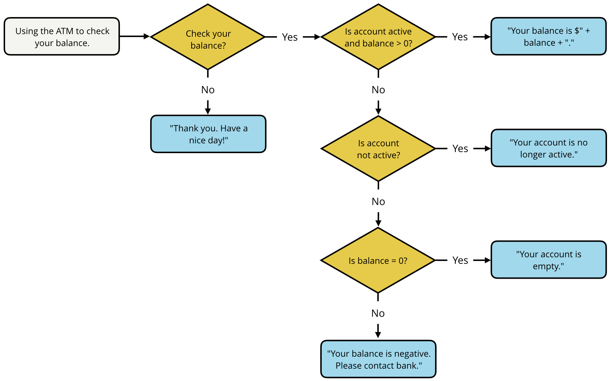

/\*

\* Programming Quiz - Checking Your Balance (3-5)

\*/

/\*

\* QUIZ REQUIREMENTS

\* 1. Your code should have the variables `balance`, `checkBalance`, `isActive`

\* 2. Your code should include an `if...else` conditional statement

\* 3. Your code should produce the expected output

\* 4. Your code should not be empty

\* 5. BE CAREFUL ABOUT THE PUNCTUATION AND THE EXACT WORDS TO BE PRINTED.

\*/

// change the values of `balance`, `checkBalance`, and `isActive` to test your code

var balance = 325.00;

var checkBalance = true;

var isActive = false;

// your code goes here

if(checkBalance === true) {

if ( balance > 0 && isActive === true){

console.log("Your balance is $" + balance.toFixed(2) + ".");

}else if (isActive === false && balance === 0){

console.log("Your account is empty.");

}else if (isActive === true && balance < 0){

console.log("Your balance is negative. Please contact bank.");

}else if (isActive === false){

console.log("Your account is no longer active.");

}

}

else {

console.log("Thank you. Have a nice day!");

}